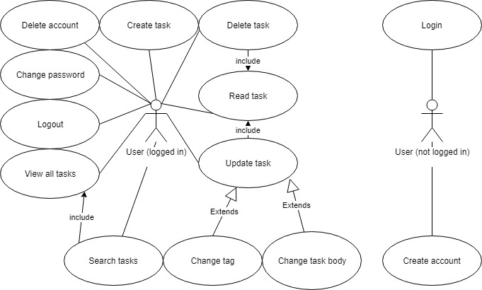**Use cases**

Create account

1. User selects option to create account
2. Application prompts user for a username and password
3. User inputs the required information
4. User submits the form
5. Application verifies that username is unique
6. Application creates a new user account and saves to database
7. Application displays a success message
8. Application loads main screen

Log in

1. User selects sign-in option
2. Application prompts user for username and password
3. User inputs the required information
4. User submits the form
5. Application verifies that the entered information is correct
6. Application loads main screen

Log out

1. User selects sign-out option
2. Application displays confirmation message
3. User confirms
4. Application logs user out
5. Application loads login screen

Delete account

1. User selects option to delete account
2. Application user password
3. User enters password and submits
4. Application confirms password is correct
5. Application deletes user account and all associated data
6. Application loads login screen

Create task

1. User selects option to create new task
2. Application displays a form for user to fill in
3. User inputs description of the task
4. Optional: User selects tag for the task
5. User submits the form
6. Application creates new task and saves to database
7. Application displays a success message
8. Application returns to main screen

Read task

1. User selects task of interest
2. Application retrieves information about task from database
3. Application displays information about task
4. User indicates that they are done reading the task
5. Application returns to main screen

Update task

1. User selects task of interest
2. Application retrieves information about task from database
3. Application displays information about task on a separate screen
4. User selects option to update task
5. Application displays a form containing the details of the task
6. User makes changes to the information as desired
7. User submits the form
8. Application updates the database with the new task data
9. Application displays a success message
10. Application returns to main screen

Delete task

1. User selects task of interest
2. Application retrieves information about task from database
3. Application displays information about task on a separate screen
4. User selects option to delete task
5. Application displays confirmation dialog
6. User confirms intention to delete task
7. Application updates database
8. Application displays success message
9. Application returns to main screen

Search tasks

1. User selects option to search all tasks
2. User enters search term and submits
3. Application retrieves list of relevant tasks from database
4. Application displays relevant tasks to user
5. User selects task of interest
6. Application displays information about task on a separate screen

Change password

1. User selects option to change password
2. Application displays a form and prompts user for current and new passwords
3. User enters required data
4. User submits form
5. Application updates the user’s password in database
6. Application displays success message
7. Application returns to main screen

**Execution Plan**

1. Setup
   1. Install Ruby on Rails
   2. Create GitHub repository
   3. Create new Rails application
2. Functionality
   1. Create router and populate with relevant routes
   2. Create controllers with relevant logic
   3. Create models based on database schemas
   4. Create views with minimal elements sufficient to display necessary data
3. Interface
   1. Add html elements to make interface more user-friendly
   2. Style html elements using CSS
4. Hosting
5. Testing
   1. Test across different browsers
   2. Test different functionalities
   3. Test unexpected occurrences
      1. User leaves halfway while creating/modifying task
      2. User attempts to create multiple accounts with same username
      3. User creates multiple identical todo tasks, then modifies/deletes one
6. Confirming requirements

**Suggestions**

* For a few seconds after deleting a todo task, application presents user with option to undo the deletion
* Visible timestamps to indicate task creation date
* Interface customization options (saved per user)
* Sort-by functionality
* Filter-by functionality

**Problems**

* Time constraint due to partially occurring during school term
* Rails pages take a somewhat lengthy time to load – may impede extensive testing
* Lack of prior experience in Rails